Տարբերակ 3

1․ Գտե՛ք թվի բոլոր բաժանարարները.
18 – 18, 9, 6, 3, 2, 1

2․ Թվերը դասավորի՛ր աճման կարգով․
54,375,452,9, 378

9, 54, 375, 378, 452

3. Հայտնի է , որ թիվը բաժանվում է 9-ի, ի՞նչ թվանշան պետք է գրված լինի *-ի փոխարեն:
7110

4. Արտահայտի՛ր 7կմ500սմ-ը մետրերով։
7000մ 500սմ
5. Բերված օրինակներում աստղանիշները փոխարինել անհրաժեշտ թվանշաններով․
ա) 3738+5231=8969
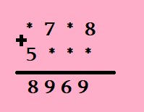
բ) 27:35=945
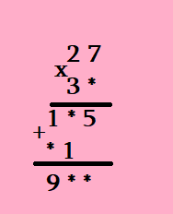

7. Ուղղանկյան երկարությունը 16 սմ է, իսկ լայնությունը 2 անգամ փոքր է երկարությունից: Գտի՛ր այդ ուղղանկյան մակերեսը:
56

8. Երկու մառաններում 1183 շիշ գինի կա, առաջինում երկրորդից 183-ով ավելի է։ Ամեն մառանում քանի՞ շիշ գինի կա։
1 – 683 2 - 500

9. Հաշվի՛ր արտահայտության արժեքը․
$\left(5000-50x5\right):10-75$=400

10․ Մի շարքում կանգնած են Անին, Դավիթը, Սյուզին, Նարեկը և Արենը: Անին գտնվում է Սյուզիից ձախ, բայց Նարեկից աջ: Նարեկն ու Արենը իրար կողք կանգնած չեն, իսկ Դավիթը չի գտնվում ո՛չ Նարեկի կողքը, ո՛չ Արենի կողքը, ո՛չ էլ Անիի կողքը: Ի՞նչ հերթականությամբ են կանգնած նրանք: Նարեկ, Անի, Արեն, Սյուզի, Դավիթ
Գործնական աշխատանք
Ֆոտոշարքը պարտադիր է, որպեսզի տեսանելի լինի, որ աշխատանքը դուք եք կատարել։ Կարող եք պատրաստել նաև տեսաֆիլմ։
https://syuzanasargsyan.edublogs.org/2022/08/16/%d5%b4%d5%a1%d5%a9%d5%a5%d5%b4%d5%a1%d5%bf%d5%ab%d5%af%d5%a1-3/

